Executive Summary
The Nepalese Student Association (NSA) Website is a web-based management platform developed to improve communication, transparency, and engagement among students and administrators of the Nepalese Student Association. Traditional methods of sharing information through social media platforms and messaging applications often resulted in fragmented communication, missed announcements, and inefficient management of association activities. To address these challenges, the NSA Website was developed as a centralized platform that integrates event management, notice dissemination, survey collection, job opportunity sharing, and user management functionalities.
The system was designed and implemented using modern web technologies including React.js for the frontend, Node.js and Express.js for the backend, and MySQL as the database management system. The platform was deployed using Railway cloud services to provide accessibility and reliability. Security features such as JSON Web Token (JWT) authentication, password hashing using bcrypt, and email-based OTP verification were implemented to ensure secure user access and account management.
The development process followed Software Engineering principles including requirements analysis, architectural design, detailed design, implementation, testing, and deployment. Various UML artifacts including use case diagrams, class diagrams, sequence diagrams, and an entity relationship diagram were created to support system analysis and design. Comprehensive testing was conducted to validate functional requirements and system reliability.
The completed system provides students with convenient access to events, notices, surveys, and job opportunities while enabling administrators to efficiently manage association operations. The project demonstrates the practical application of software engineering methodologies and modern web development technologies in solving real-world organizational challenges.
Overall, the NSA Website successfully fulfills its primary objectives and establishes a scalable foundation for future enhancements and continued digital transformation within the Nepalese Student Association.

Table of Contents
Description Pages
1. Introduction…………………………………………………………………………..…………….
1.1 Purpose and Scope………………………………………………………………….……….
1.2 Product Overview…………………………………………………………………..…………
1.3 Structure of the Document………………………………………………….…..…………
1.4 Terms, Acronyms and Abbreviations………………………………………….…………
2. Project Management Plan…………………………………………………………….………….
2.1 Project Organization…………………………………………………………….…………….
2.2 Lifecycle Model Used……………………………………………………..….……………….
2.3 Risk Analysis………………………………………………………………………..…………….
2.4 Hardware and Software Resource Requirements………………………………………
2.5 Deliverables and Schedule…………………………………………………………………….
2.6 Monitoring, Reporting and Controlling Mechanisms……………………..……………
2.7 Professional Standards………………………………………………………………………….
2.8 Configuration Management…………………………………………………………………….
2.9 Impact on Individuals and Organizations…………………………………….……………
3. Requirement Specifications……………………………………………………………………….
3.1 Stakeholders for the System…………………………………………….…………………….
3.2 Use Case Model………………………………………………………………….……………….
3.2.1 Graphic Use Case Model……………………………………………………………………….
3.2.2 Textual Description for Each Use Case……………………………….……………………
3.3 Rationale for Use Case Model………………………………………….………………………
3.4 Non-Functional Requirements…………………………………………………………………
4. Architecture …………………………………………………………………………………..………….
4.1 Architectural Style Used………………………………………………………………………….
4.2 Architectural Model…………………………………………………………………………….
4.3 Technology, Software and Hardware Used………………………………………………
4.4 Rationale for Architectural Style and Model……………………………………………
5. Design……………………………………………………………………………………………………
5.1 GUI Design……………………………………………………………………………………….
5.2 Static Model – Class Diagram………………………………………………………………
5.3 Dynamic Model – Sequence Diagrams……………………………………………………
5.4 Rationale for Detailed Design Model……………………………………………………….
5.5 Traceability from Requirements to Design…………………………………………………
6. Test Plan………………………………………………………………………………………………….….
6.1 Requirements-Based System Level Test Cases……………………….……………………
6.2 Traceability of Test Cases to Use Cases………………………………………..……………
6.3 Techniques Used for Test Generation……………………………………………………………
6.4 Assessment of the Goodness of the Test Suite…………………………….…….……………
7. Acknowledgment………………………………………………………………………………….……….
8. References………………………………………………………………………..………………………….
Figure 3.1 Context Diagram
Figure 3.2 Administrator Use Case Diagram
Figure 3.3 Student Use Case Diagram
Figure 4.1 Three-Tier Architecture Diagram
Figure 5.1 Login Page Interface
Figure 5.2 Registration Page Interface
Figure 5.3 Student Dashboard Interface
Figure 5.4 Administrator Dashboard Interface
Figure 5.5 Event Management Interface
Figure 5.6 Notice Management Interface
Figure 5.7 Job Portal Interface
Figure 5.8 Survey Management Interface
Figure 5.9 Entity Relationship Diagram
Figure 5.10 Class Diagram
Figure 5.11 Sequence Diagram – User Login
Figure 5.12 Sequence Diagram – Admin Creates Event
Figure 5.13 Sequence Diagram – Student Submits Survey
Figure 5.14 Sequence Diagram – Admin Posts Job

Chapter 1
Introduction
1.1 Purpose and Scope
The Nepalese Student Association (NSA) Website is a web-based platform developed to improve communication, information sharing, event management, and student engagement among Nepalese students at Dongshin University. Traditionally, important information regarding events, notices, surveys, job opportunities, and financial activities was shared through social media platforms and messaging applications, which often resulted in scattered information, missed announcements, and inefficient communication.
The purpose of this project is to provide a centralized digital platform where students and administrators can efficiently manage and access association-related information. The system enables administrators to create and manage events, notices, job opportunities, surveys, budgets, and user accounts, while students can access these services through a secure and user-friendly interface.
The scope of the project includes:
- User registration and authentication
- Role-based access control (Admin and Student)
- Event management system
- Notice board management
- Job opportunity portal
- Student survey system
- Budget transparency module
- User management system
- Secure database storage and retrieval
- Responsive web interface accessible from multiple devices
The system does not include payment processing, direct messaging, or mobile application support in the current version.

1.2 Product Overview
The NSA Website is a full-stack web application designed to serve as the official digital platform for the Nepalese Student Association. The system follows a three-tier client-server architecture consisting of a React frontend, Node.js/Express backend, and MySQL database.
Key Capabilities
- User Management
Students can register and create accounts using their academic information. Administrators can manage user accounts and assign permissions.
- Authentication and Security
The platform provides secure login functionality using encrypted passwords and JSON Web Tokens (JWT). Email-based OTP verification is also integrated for account validation and password recovery.
- Event Management
Administrators can create, update, and delete events. Students can view upcoming events through a centralized event dashboard.
- Notice Management
Administrators can publish official announcements through a digital notice board. Students can access notices in real time.
- Job Portal
Administrators can post employment opportunities, while students can browse and apply for available positions.
- Survey System
Administrators can create surveys to collect student feedback, and students can participate in surveys directly through the platform.
- Budget Transparency
Administrators can maintain budget records, and students can access financial summaries to promote transparency within the association.

Typical Usage Scenario
A student registers for the NSA Website and verifies their email address through an OTP. After logging in, the student can:
- View upcoming events
- Read official notices
- Browse available jobs
- Participate in surveys
- Review budget summaries
An administrator logs into the system and can:
- Manage users
- Create and update events
- Publish notices
- Post job opportunities
- Create surveys
- Manage budget information
The platform serves as a centralized hub for all association activities and communications.

1.3 Structure of the Document
This report is organized into six major chapters:
Chapter 1 – Introduction
Provides the project purpose, scope, product overview, and document organization.
Chapter 2 – Project Management Plan
Describes project organization, development methodology, resource allocation, risks, schedules, and project management activities.
Chapter 3 – Requirement Specifications
Presents stakeholders, use case models, functional requirements, and non-functional requirements.
Chapter 4 – Architecture
Explains the system architecture, technology stack, architectural design decisions, and implementation environment.
Chapter 5 – Design
Describes the graphical user interface, class diagrams, sequence diagrams, database design, and traceability from requirements to design.
Chapter 6 – Test Plan
Provides system-level test cases, testing techniques, test coverage analysis, and traceability between requirements and testing activities.
The report concludes with acknowledgments and references used throughout the project.

1.4 Terms, Acronyms, and Abbreviations
Term | Description
NSA | Nepalese Student Association
GUI | Graphical User Interface
JWT | JSON Web Token
RBAC | Role-Based Access Control
API | Application Programming Interface
DBMS | Database Management System
MySQL | Relational Database Management System used in the project
OTP | One-Time Password
SMTP | Simple Mail Transfer Protocol
CRUD | Create, Read, Update, Delete
FE | Frontend
BE | Backend
UML | Unified Modeling Language
ER Diagram | Entity Relationship Diagram
HTTP | Hypertext Transfer Protocol
HTTPS | Hypertext Transfer Protocol Secure
React | Frontend JavaScript Library
Node.js | Server-side JavaScript Runtime Environment
Express.js | Web Framework for Node.js
Vite | Frontend Build Tool
Git | Version Control System
GitHub | Source Code Repository Platform

Chapter 2
Project Management Plan
2.1 Project Organization
The NSA Website project was developed as part of the Software Engineering course (ITS10-02) at Dongshin University. The project team was responsible for gathering requirements, designing the system architecture, implementing the software solution, testing the system, and preparing project documentation.
The project was organized using a collaborative team structure where responsibilities were distributed among team members according to system modules and expertise.
Team Roles and Responsibilities
Role | Responsibility
Project Manager | Planning, scheduling, coordination, progress monitoring, and report preparation
Backend Developer | Development of REST APIs, database integration, authentication, and business logic
Frontend Developer | User interface development, page navigation, and user experience design
Database Designer | Database design, schema creation, and data management
Tester | Functional testing, bug identification, and validation
Documentation Manager | Preparation of SRS, design documents, RTM, and final report
Although responsibilities were distributed, all members participated in discussions, testing, and design reviews throughout the development process.

Organizational Structure

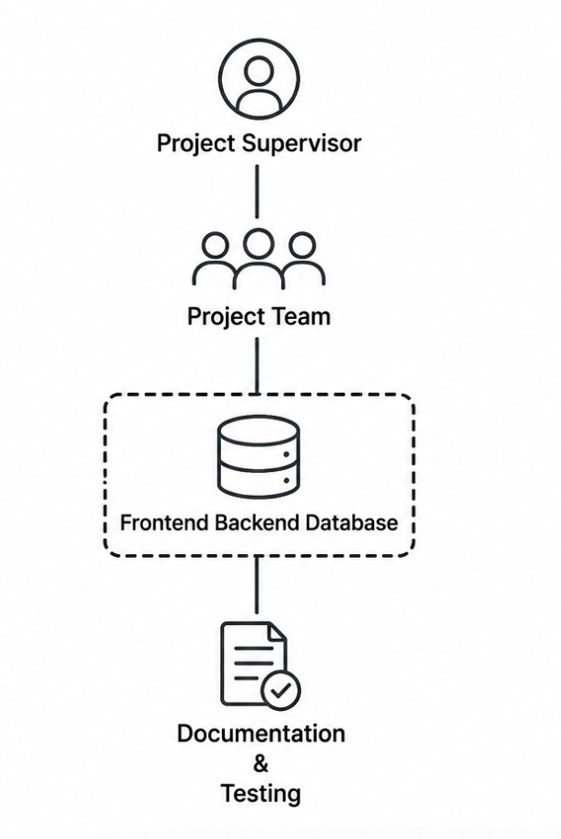

Figure 1: Organizational Structure

2.2 Lifecycle Model Used
The project adopted the Agile Software Development Model.
Agile was selected because it allows continuous development, frequent testing, and iterative improvement of software features. Since requirements evolved during the development process, Agile provided flexibility for incorporating feedback and modifications.
Agile Development Process
The development process was divided into several iterations:
Iteration 1 – Requirements Analysis
- Stakeholder identification
- Requirement gathering
- SRS preparation
- Use case development
Iteration 2 – System Design
- Architecture design
- Database design
- Class diagrams
- Sequence diagrams
Iteration 3 – Backend Development
- Authentication system
- User management APIs
- Event APIs
- Notice APIs
- Job APIs
- Survey APIs

Iteration 4 – Frontend Development
- Registration page
- Login page
- Dashboard
- Event management interface
- Job portal
- Survey system
Iteration 5 – Testing and Integration
- Functional testing
- API testing
- Database testing
- Bug fixing
Iteration 6 – Deployment and Documentation
- Railway deployment
- Database migration
- Final report preparation
Advantages of Agile for this Project
- Supports changing requirements.
- Enables early testing.
- Improves collaboration.
- Allows continuous improvement.
- Facilitates incremental delivery.

2.3 Risk Analysis
Risk management was performed throughout the project lifecycle to identify and mitigate potential issues.
Risk Assessment Table
Risk | Probability | Impact | Mitigation Strategy
Requirement changes | Medium | High | Regular stakeholder discussions
Database connection failures | High | High | Backup database configuration and testing
Deployment issues | High | Medium | Continuous deployment testing on Railway
Team communication problems | Medium | Medium | Weekly progress meetings
Security vulnerabilities | Medium | High | JWT authentication and password hashing
Data loss | Low | High | Regular database backups
Schedule delays | Medium | Medium | Milestone tracking and task prioritization
Third-party email service failure | Medium | Medium | Alternative email service providers

Risk Mitigation Examples
During deployment, the team experienced package dependency conflicts and SMTP email delivery issues. These risks were mitigated by updating package-lock files, using cloud-hosted databases, and integrating Brevo email services as an alternative communication solution.

2.4 Hardware and Software Resource Requirements
Hardware Requirements
Development Environment
Hardware | Specification
Processor | Intel Core i5 or higher
RAM | 8 GB minimum
Storage | 256 GB SSD minimum
Internet | Broadband connection
Device | Laptop/Desktop

Deployment Environment
Component | Specification
Railway Cloud Platform | Application Hosting
Railway MySQL Service | Cloud Database
Cloud Storage | Application Data

Software Requirements
Software | Purpose
Visual Studio Code | Source code development
Node.js | Backend runtime
Express.js | Web framework
React.js | Frontend development
Vite | Frontend build tool
MySQL | Database management
Railway | Cloud deployment
Git | Version control
GitHub | Source code repository
Postman | API testing
Figma | UI design
MySQL Workbench | Database administration

New Technologies Learned During the Project
Technology | Learning Outcome
React.js | Component-based frontend development
Express.js | RESTful API development
JWT Authentication | Secure user authentication
Railway Deployment | Cloud application hosting
MySQL Integration | Database connectivity and management
Git & GitHub | Collaborative version control
Figma | Interface prototyping
SMTP/Brevo API | Email and OTP services
The project provided valuable practical experience in full-stack web application development and cloud deployment technologies.

2.5 Deliverables and Schedule
Project Deliverables
Deliverable | Status
Software Requirements Specification (SRS) | Completed
Context Diagram | Completed
Use Case Diagram | Completed
ER Diagram | Completed
Class Diagram | Completed
Sequence Diagrams | Completed
Frontend Application | Completed
Backend APIs | Completed
Database Schema | Completed
Testing Report | Completed
Final Report | Completed
Deployment on Railway | Completed

Project Schedule
Phase | Duration
Requirement Analysis | Week 1-2
System Design | Week 3-4
Database Design | Week 5
Backend Development | Week 6-8
Frontend Development | Week 9-11
Integration Testing | Week 12
Deployment | Week 13
Documentation | Week 14

2.6 Monitoring, Reporting, and Controlling Mechanisms
Project progress was monitored through regular team meetings and milestone reviews.
Monitoring Techniques
- Weekly progress discussions
- Task completion tracking
- GitHub commit monitoring
- Feature completion reviews
- API testing reports
Reporting Methods
- Weekly status reports
- GitHub commit history
- Project demonstrations
- Design review sessions
Control Mechanisms
- Version control using Git
- Code review before merging
- Requirement Traceability Matrix (RTM)
- Testing and bug tracking
These mechanisms ensured project quality and schedule adherence.

2.7 Professional Standards
The project followed recognized software engineering standards and best practices.
Standards Applied
Coding Standards
- Consistent naming conventions
- Modular programming
- Code documentation
Security Standards
- Password hashing using bcrypt
- JWT authentication
- Input validation
- Protected API routes
Documentation Standards
- IEEE Software Engineering Report Format
- UML Modeling Standards
- Requirement Traceability Matrix (RTM)
Database Standards
- Relational database design
- Foreign key constraints
- Data integrity enforcement

2.8 Evidence That All Artifacts Were Placed Under Configuration Management
Configuration management was implemented using Git and GitHub.
Repository Management
The NSA Website source code, documentation, diagrams, and reports were stored in a centralized GitHub repository.
Artifacts under version control included:
- Source code
- SRS document
- Design diagrams
- Testing artifacts
- Final report
- Database scripts
Configuration Management Activities
- Version tracking
- Branch management
- Commit history maintenance
- Code merging
- Backup storage
GitHub provided traceability and ensured all project artifacts remained synchronized throughout development.

2.9 Impact of the Project on Individuals and Organizations
Impact on Students
The NSA Website improves communication and information accessibility for students by providing a centralized platform for events, notices, jobs, and surveys.
Benefits include:
- Faster access to information
- Increased student engagement
- Better employment opportunities
- Improved communication
- Increased transparency
Impact on the Nepalese Student Association
The platform modernizes association operations by replacing manual communication methods with a centralized digital system.
Benefits include:
- Efficient event management
- Simplified notice distribution
- Better survey collection
- Improved budget transparency
- Reduced administrative workload
Impact on Society
The project demonstrates how digital technologies can enhance community organizations and student associations. It promotes transparency, accountability, and accessibility while encouraging digital transformation in educational communities.
Educational Impact
The project enabled team members to gain practical experience in:
- Software Engineering
- Web Development
- Database Systems
- Cloud Deployment
- Team Collaboration
- Project Management
The experience significantly improved both technical and professional skills, preparing team members for future software development careers.

Chapter 3
Requirement Specifications
3.1 Stakeholders for the System
Stakeholders are individuals or organizations that interact with or are affected by the NSA Website system.
Primary Stakeholders
- Nepalese Student Association (NSA) Administrators
Administrators are responsible for managing the entire system. They create events, publish notices, manage surveys, oversee job postings, and maintain user accounts.
Responsibilities:
- Manage events
- Post notices
- Create surveys
- Approve content
- Manage users
- Monitor system activities
- Students
Students are the primary users of the system. They use the platform to access announcements, register for events, participate in surveys, and browse job opportunities.
Responsibilities:
- Register accounts
- Login to the system
- View notices
- Participate in surveys
- Apply for jobs
- Update profile information
Secondary Stakeholders
- Employers
Employers provide job opportunities for students through the Job Portal module.
Responsibilities:
- Submit job postings
- Recruit students
- Communicate opportunities

- University Community
The broader university community benefits from improved communication and event management.
Benefits:
- Easier information dissemination
- Increased student participation
- Better organization of activities

- Development Team
The development team designs, implements, tests, and maintains the system.
Responsibilities:
- Software development
- Bug fixing
- System deployment
- Maintenance

Stakeholder Relationship Diagram
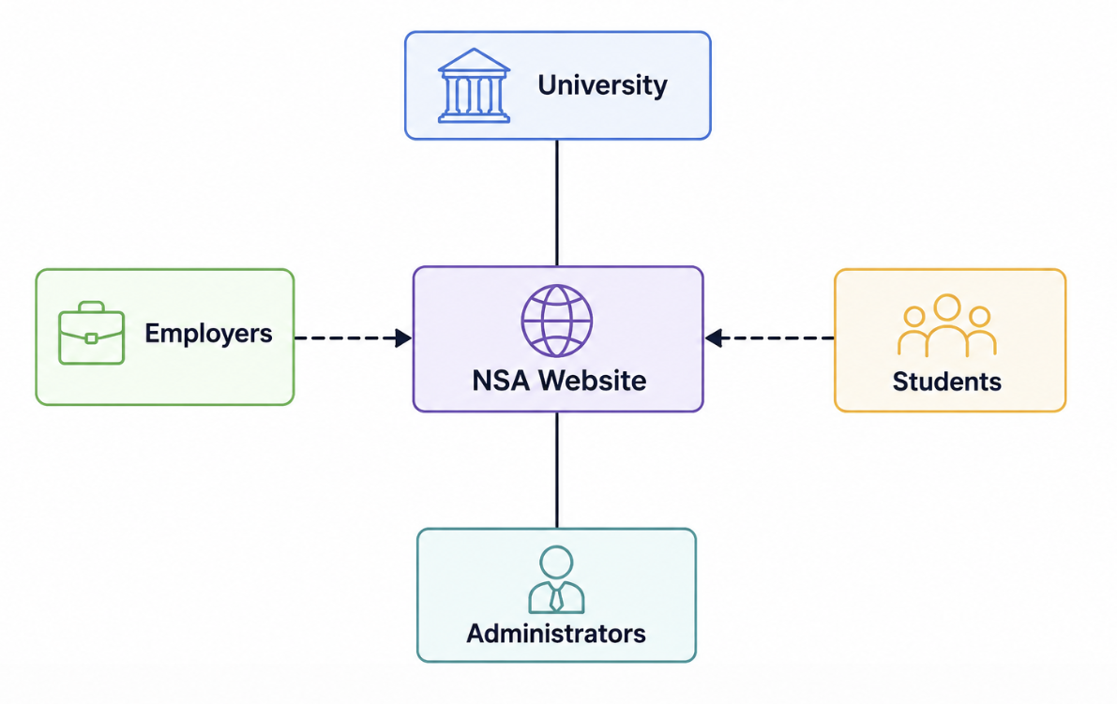
Figure 2: Stakeholder Relationship Diagram

3.2 Use Case Model
The use case model describes the interactions between users and the NSA Website system.
Figure 3.2.1: NSA Website Use Case Diagram
The use case model contains two actors:
- Student
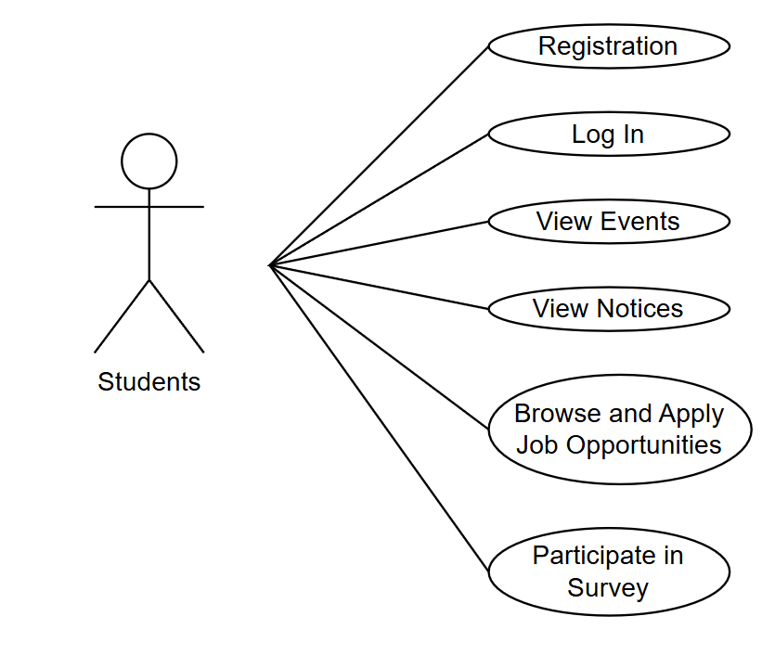
Figure 3: Use case diagram-Student
Student can:
- Register Account
- Verify OTP
- Login
- Manage Profile
- View Events
- View Notices
- Browse Jobs
- Submit Surveys
- Logout

- Administrator
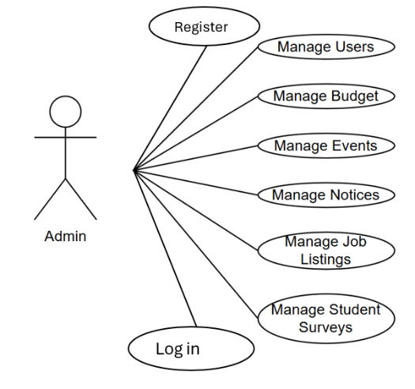
Figure 4: Use case diagram-Admin
Administrator can:
- Login
- Manage Events
- Manage Notices
- Manage Surveys
- Manage Jobs
- Manage Users
- Manage Budget Records
- Logout

3.2.2 Textual Description for Each Use Case
UC-01 User Registration
Item | Description
Use Case ID | UC-01
Use Case Name | User Registration
Primary Actor | Student
Goal | Create a new user account
Preconditions | User is not registered
Postconditions | Account successfully created
Main Flow
- User opens registration page.
- User enters personal information.
- User requests OTP verification.
- System sends OTP to email.
- User enters OTP.
- System validates OTP.
- Account is created successfully.
Alternative Flow
- Invalid OTP entered.
- System displays error message.

UC-02 User Login
Item | Description
Use Case ID | UC-02
Use Case Name | User Login
Primary Actor | Student/Admin
Goal | Access the system
Preconditions | User account exists
Postconditions | User is authenticated
Main Flow
- User enters email and password.
- System validates credentials.
- JWT token is generated.
- User accesses dashboard.
Alternative Flow
- Invalid credentials.
- System displays login error.
UC-03 Manage Events
Item | Description
Use Case ID | UC-03
Use Case Name | Manage Events
Primary Actor | Administrator
Goal | Create, update, and delete events
Main Flow
- Admin opens Event Management.
- Admin creates or edits event details.
- System saves event information.
- Students can view events.

UC-04 View Events
Item | Description
Use Case ID | UC-04
Use Case Name | View Events
Primary Actor | Student
Goal | Access event information
Main Flow
- Student opens Events page.
- System displays event list.
- Student views event details.

UC-05 Manage Notices
Item | Description
Use Case ID | UC-05
Use Case Name | Manage Notices
Primary Actor | Administrator
Goal | Publish announcements
Main Flow
- Admin creates notice.
- Notice is saved.
- Notice becomes visible to users.

UC-06 View Notices
Item | Description
Use Case ID | UC-06
Use Case Name | View Notices
Primary Actor | Student
Goal | Read announcements
Main Flow
- Student opens Notice Board.
- System displays notices.
- Student reads details.

UC-07 Manage Surveys
Item | Description
Use Case ID | UC-07
Use Case Name | Manage Surveys
Primary Actor | Administrator
Goal | Create surveys
Main Flow
- Admin creates survey questions.
- Survey is published.
- Students can participate.

UC-08 Submit Survey
Item | Description
Use Case ID | UC-08
Use Case Name | Submit Survey
Primary Actor | Student
Goal | Participate in surveys
Main Flow
- Student opens survey.
- Student answers questions.
- System stores responses.

UC-09 Manage Job Listings
Item | Description
Use Case ID | UC-09
Use Case Name | Manage Job Listings
Primary Actor | Administrator
Goal | Publish employment opportunities
Main Flow
- Admin creates job listing.
- Job is stored.
- Students can browse opportunities.

UC-10 Browse Jobs
Item | Description
Use Case ID | UC-10
Use Case Name | Browse Jobs
Primary Actor | Student
Goal | Search available jobs
Main Flow
- Student opens Job Portal.
- System displays available jobs.
- Student reviews job details.

UC-11 Manage Budget Records
Item | Description
Use Case ID | UC-11
Use Case Name | Manage Budget Records
Primary Actor | Administrator
Goal | Maintain financial records
Main Flow
- Admin enters budget information.
- System stores budget records.
- Reports become available.

UC-12 Manage User Accounts
Item | Description
Use Case ID | UC-12
Use Case Name | Manage Users
Primary Actor | Administrator
Goal | Manage system users
Main Flow
- Admin accesses user management.
- Admin updates user information.
- System saves changes.

3.3 Rationale for the Use Case Model
The use case model was developed to clearly identify the functional requirements and interactions between system users and the NSA Website.
The model separates responsibilities between students and administrators, ensuring proper access control and security. Students focus on consuming information and participating in activities, while administrators manage content and system operations.
The selected use cases directly support the primary objectives of the project:
- Improve communication within the Nepalese Student Association.
- Centralize event management.
- Provide employment opportunities.
- Enable survey collection.
- Improve transparency and information accessibility.
The use case model also served as the foundation for system design, class diagrams, sequence diagrams, database design, and testing activities.

3.4 Non-Functional Requirements
The NSA Website must satisfy several quality requirements in addition to functional requirements.
Performance Requirements
Requirement ID | Description
NFR-01 | System shall respond to user requests within 3 seconds under normal conditions.
NFR-02 | System shall support at least 100 concurrent users.
NFR-03 | Database queries shall complete within 2 seconds.

Security Requirements
Requirement ID | Description
NFR-04 | User passwords shall be encrypted using bcrypt hashing.
NFR-05 | Authentication shall be implemented using JWT tokens.
NFR-06 | Unauthorized users shall not access protected resources.

Reliability Requirements
Requirement ID | Description
NFR-07 | System availability shall be at least 99%.
NFR-08 | Database backups shall be maintained regularly.
NFR-09 | System shall recover from failures without data loss.

Usability Requirements
Requirement ID | Description
NFR-10 | User interface shall be intuitive and easy to navigate.
NFR-11 | New users shall learn basic functions within 15 minutes.
NFR-12 | System shall provide meaningful error messages.

Maintainability Requirements
Requirement ID | Description
NFR-13 | System architecture shall support future enhancements.
NFR-14 | Source code shall follow modular programming practices.
NFR-15 | Documentation shall be maintained throughout development.

Portability Requirements
Requirement ID | Description
NFR-16 | System shall operate on modern web browsers.
NFR-17 | System shall support Windows, Linux, and macOS platforms.
NFR-18 | Cloud deployment shall be supported through Railway.

Chapter 4
Architecture
4.1 Architectural Style(s) Used
The NSA Website follows a Three-Tier Client-Server Architecture combined with a RESTful API Architecture. This architectural style separates the presentation layer, business logic layer, and data layer, making the system scalable, maintainable, and easier to develop.
Three-Tier Architecture
The architecture consists of three layers:
1. Presentation Layer (Frontend)
The presentation layer provides the graphical user interface (GUI) through which users interact with the system.
Responsibilities:
- Display web pages
- Collect user inputs
- Send requests to the backend
- Display server responses
Technology Used:
- React.js
- Bootstrap 5
- Axios
- React Router DOM

2. Business Logic Layer (Backend)
The business logic layer processes user requests and implements system functionality.
Responsibilities:
- User authentication
- OTP verification
- Event management
- Notice management
- Job portal operations
- Survey processing
- Budget management
Technology Used:
- Node.js
- Express.js
- JWT Authentication
- Nodemailer/Brevo Email Service

3. Data Layer (Database)
The data layer stores and retrieves system data.
Responsibilities:
- Store user accounts
- Store events
- Store notices
- Store surveys
- Store job listings
- Store budget records

Technology Used:
- MySQL
- Railway Cloud Database

4.2 Architectural Model
System Architecture Diagram

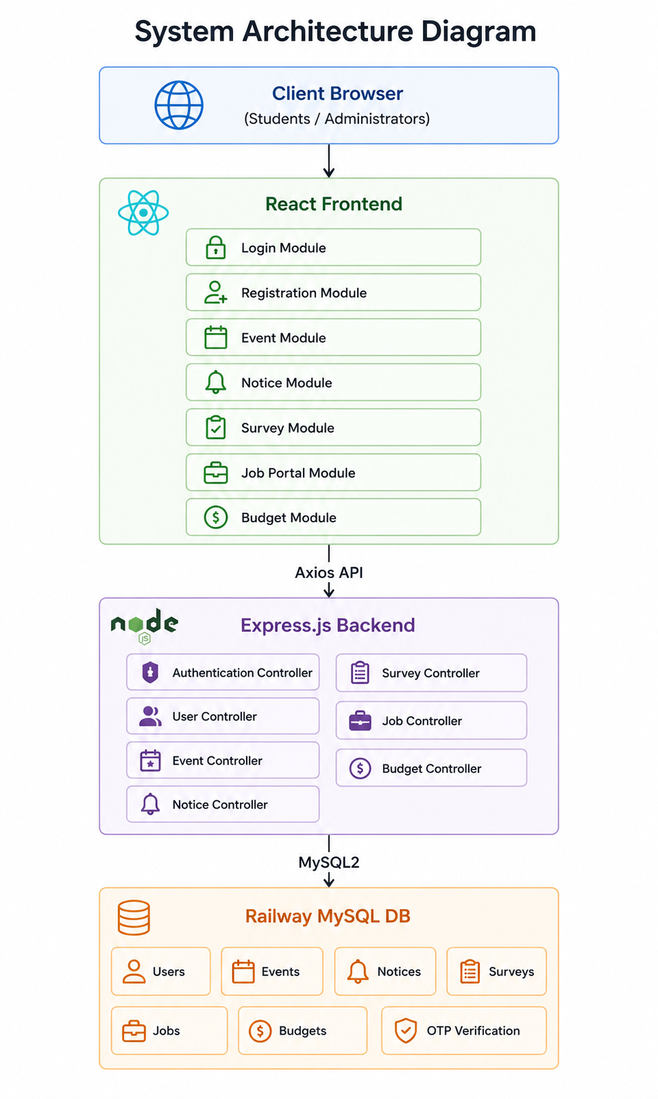
Figure 5: Overall System Architecture
Request Processing Flow
- User accesses NSA Website through browser.
- React frontend sends API request using Axios.
- Express backend receives request.
- Controller processes business logic.
- MySQL database executes query.
- Database returns result.
- Backend sends JSON response.
- Frontend updates interface.

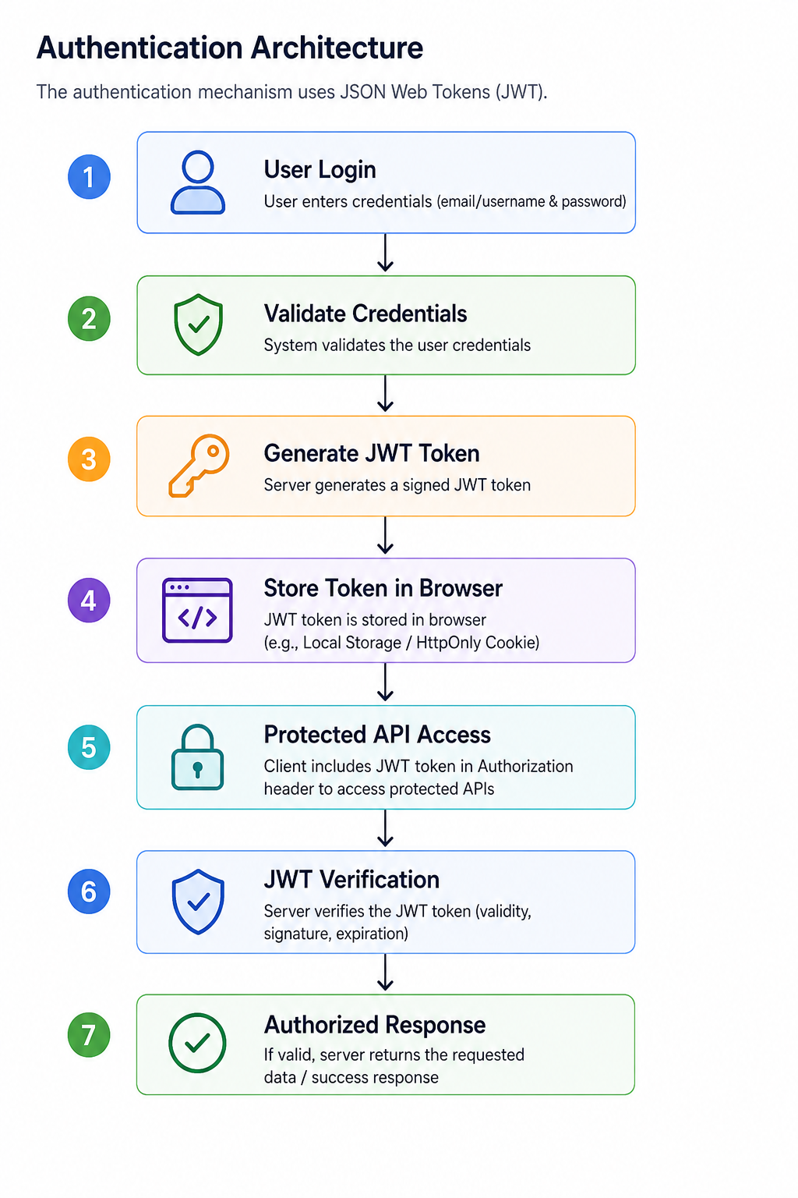
Authentication Architecture
The authentication mechanism uses JSON Web Tokens (JWT).

Figure 6: Authentication Architecture

Email Verification Architecture
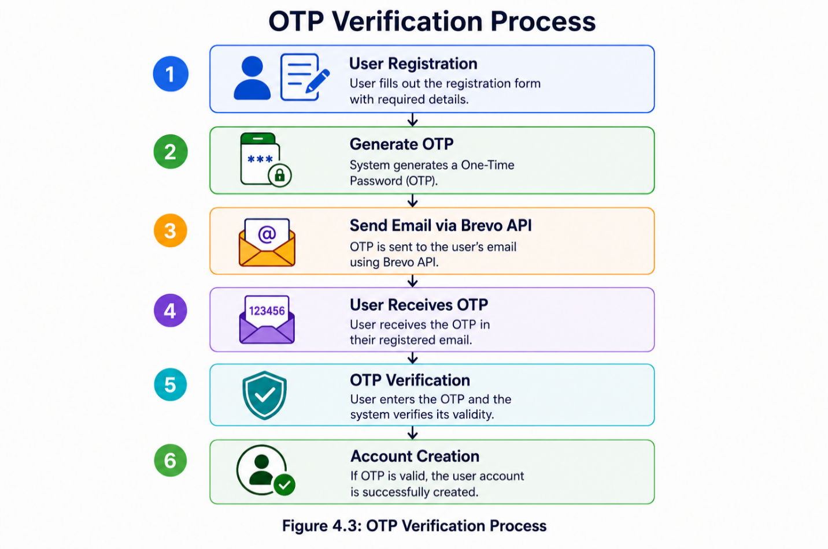

Figure 7: OTP Verification Process

4.3 Technology, Software, and Hardware Used
Software Technologies
Category | Technology
Frontend Framework | React.js
Styling Framework | Bootstrap 5
Backend Runtime | Node.js
Backend Framework | Express.js
Database | MySQL
Authentication | JWT
Password Encryption | bcrypt
API Communication | Axios
Email Service | Brevo API
Version Control | Git
Repository Hosting | GitHub
Cloud Hosting | Railway
IDE | Visual Studio Code
Database Management | MySQL Workbench
Testing Tools | Postman
Documentation | Microsoft Word

Hardware Requirements
Development Environment
Component | Specification
Processor | Intel Core i5 or higher
RAM | Minimum 8 GB
Storage | 256 GB SSD
Internet | Broadband Connection
Operating System | Windows 11

Hardware Used by Team Members
Member | Hardware Used
Sabin | Windows Laptop, Intel Processor, VS Code
Milan | Windows Laptop
Ramuna | Windows Laptop
Anish | Windows Laptop
Sumit | Windows Laptop

New Technologies Learned During the Project
Sabin
- Railway Cloud Deployment
- JWT Authentication
- MySQL Cloud Integration
- Brevo Email API
- React Router
- Git Branch Management
Milan
- React Components
- Frontend State Management
- Bootstrap Integration
Ramuna
- MySQL Database Design
- REST API Development
Anish
- Software Testing
- Documentation Preparation
Sumit
- React Components
- Frontend State Management
- Bootstrap Integration

4.4 Rationale for Architectural Style and Model
The Three-Tier Architecture was selected because it provides clear separation of concerns between the user interface, business logic, and database layers.
Advantages
- Maintainability
Changes in one layer do not significantly affect other layers. For example, frontend modifications can be implemented without changing the database structure.
- Scalability
Additional modules such as attendance tracking, membership management, or mobile applications can be integrated easily.
- Security
Sensitive information is processed on the server side. JWT authentication and password encryption enhance security.
- Reusability
Backend APIs can be reused by future mobile applications or external systems.
- Cloud Compatibility
The architecture supports deployment on cloud platforms such as Railway, making the system accessible from anywhere.

Why React + Express + MySQL?
React
- Fast user interface rendering
- Component-based architecture
- Reusable code structure
Express
- Lightweight backend framework
- Easy API development
- High compatibility with React
MySQL
- Reliable relational database
- Easy integration with Node.js
- Strong support for structured data
Railway
- Simplified deployment process
- Cloud database hosting
- Continuous deployment through GitHub

Chapter 5
Design
5.1 GUI (Graphical User Interface) Design
The Graphical User Interface (GUI) of the NSA Website was designed to provide a modern, responsive, and user-friendly experience for both students and administrators. The interface was initially prototyped using Figma and later implemented using React.js and Bootstrap.
The design emphasizes simplicity, accessibility, and ease of navigation while maintaining a professional appearance suitable for an academic organization.
Design Principles
The GUI was developed according to the following principles:
- Simplicity and ease of use
- Consistent navigation structure
- Responsive design for multiple devices
- Clear visual hierarchy
- Minimal learning curve for users

Main Interfaces
- Login Interface
The Login Page provides secure access to the platform for students and administrators. Users enter their email address and password, which are validated by the backend authentication service.
Features:
- Email authentication
- Password authentication
- Forgot Password functionality
- Secure JWT-based login

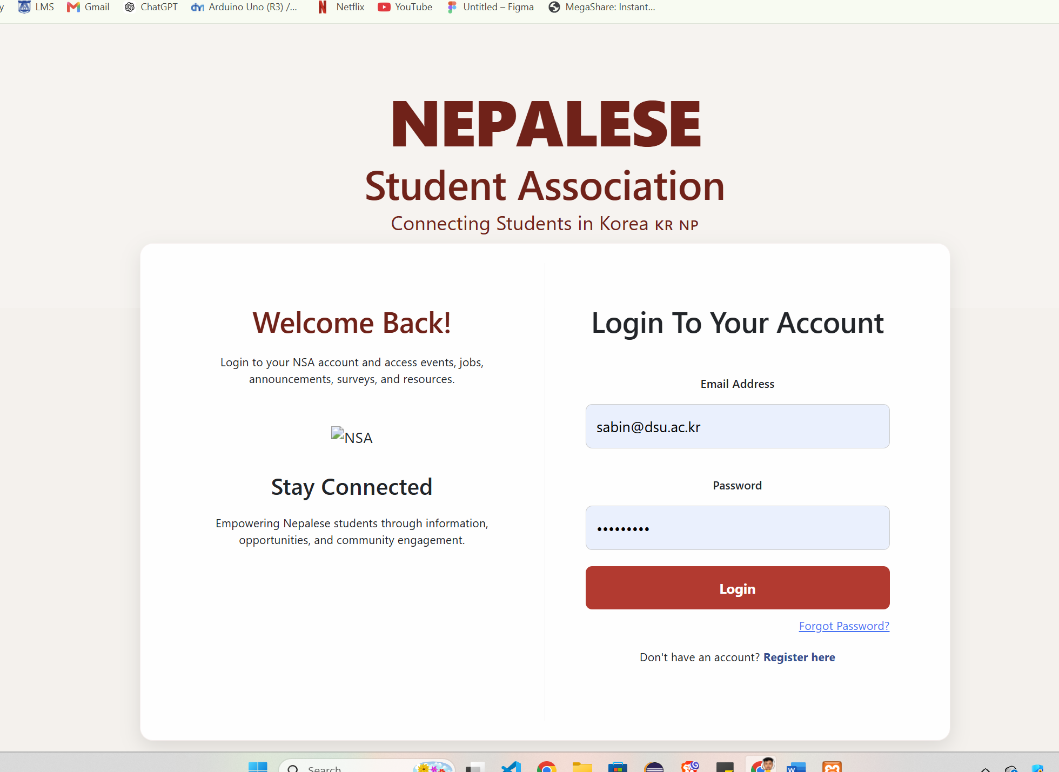
Figure 8: Login Page Screenshot

- Registration Interface
The Registration Page allows students to create accounts by entering personal and academic information. Email verification using OTP ensures account authenticity.
Features:
- Student information entry
- OTP verification
- Password confirmation
- Input validation
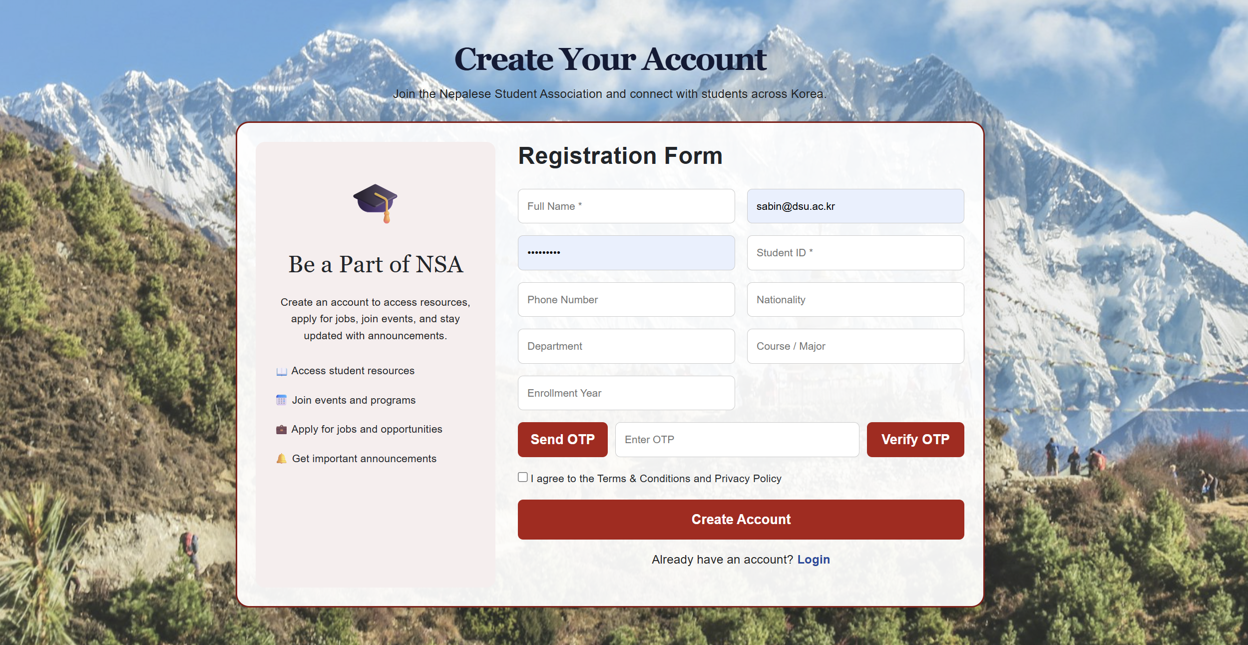
Figure 9: Registration Page Screenshot

- Student Dashboard
The Student Dashboard serves as the central hub for students after successful login.
Features:
- Event announcements
- Notice board access
- Job opportunities
- Survey participation
- User profile management
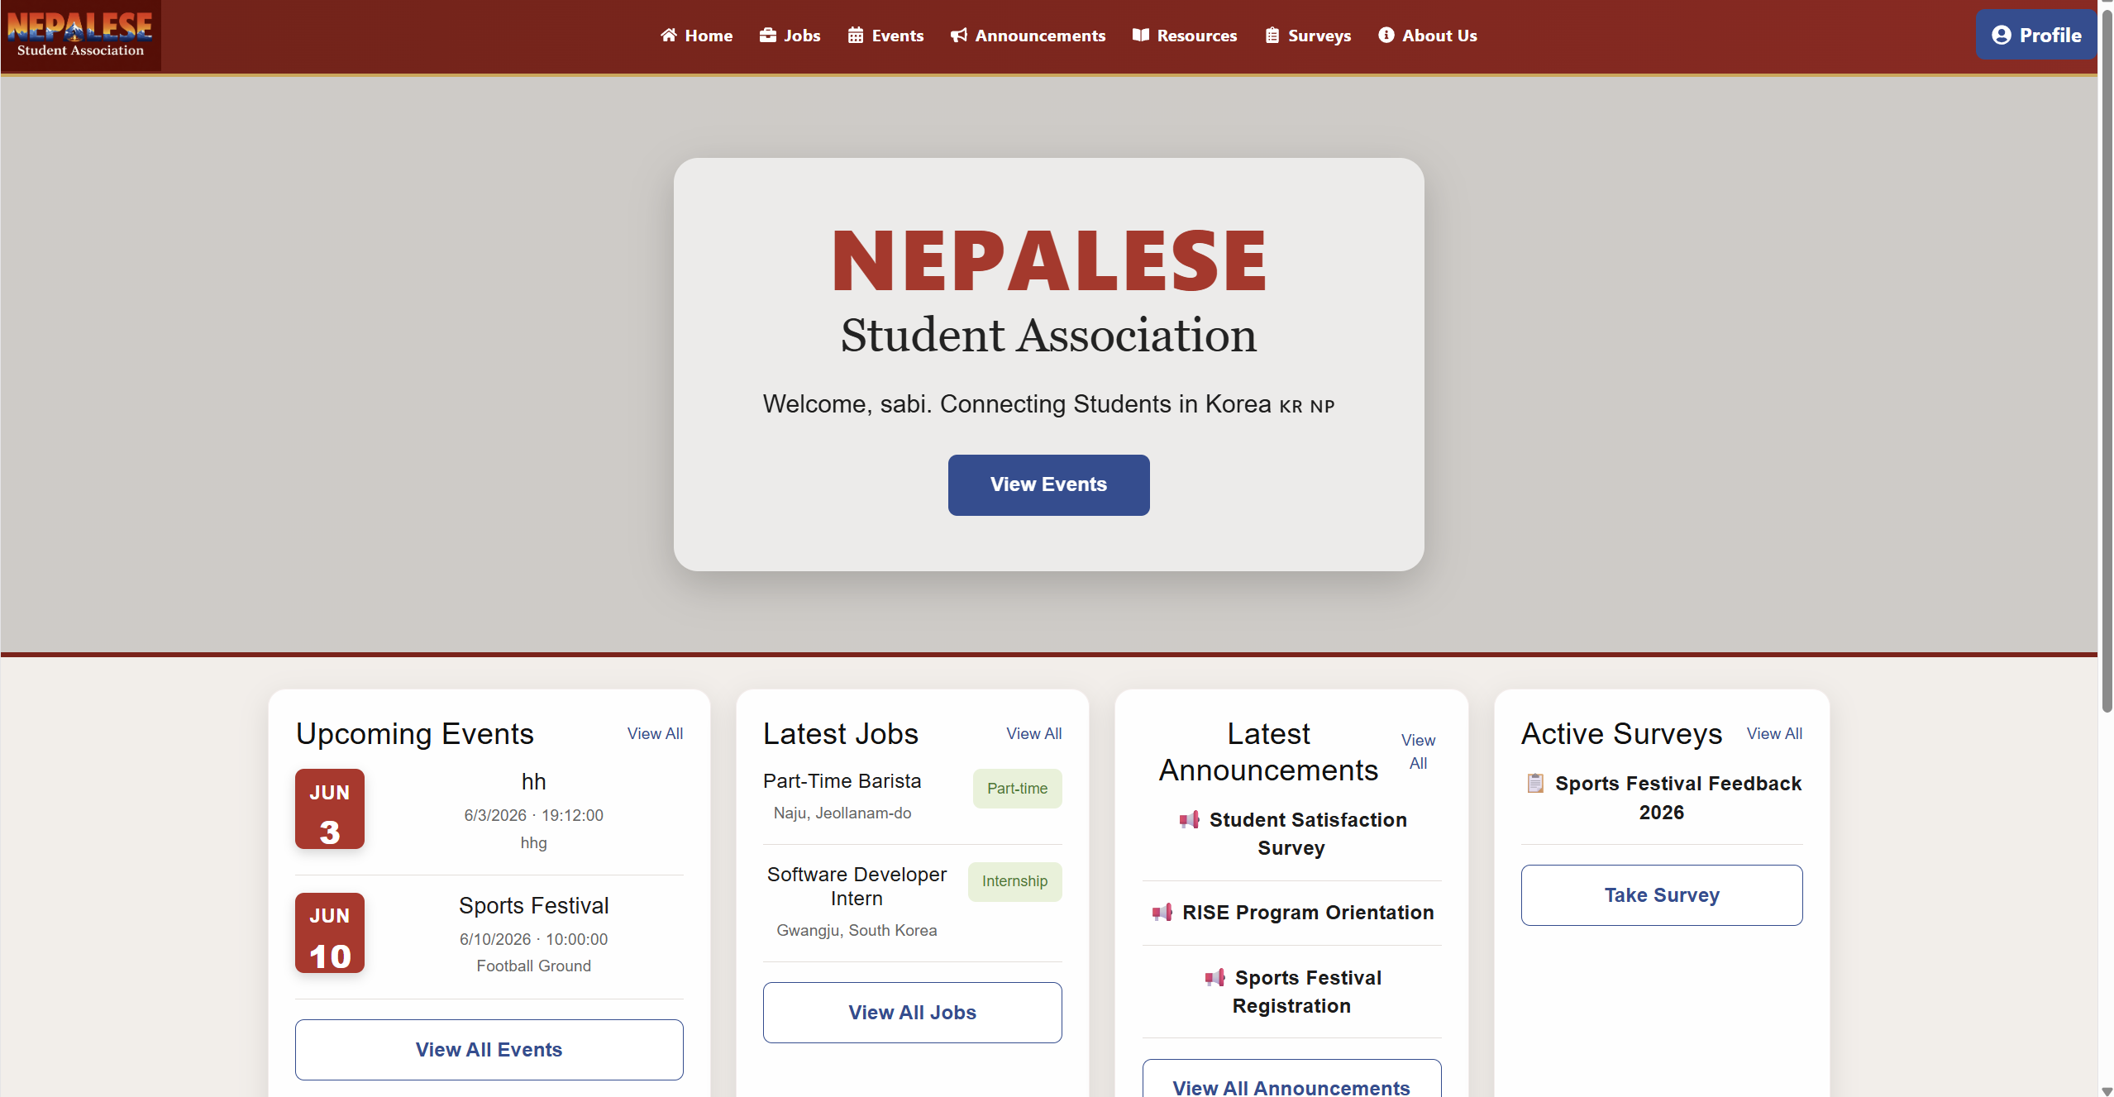
Figure 10: Student Dashboard Screenshot

- Administrator Dashboard
The Administrator Dashboard provides management tools for association executives.
Features:
- Event Management
- Notice Management
- Survey Management
- Job Management
- User Management
- Budget Management
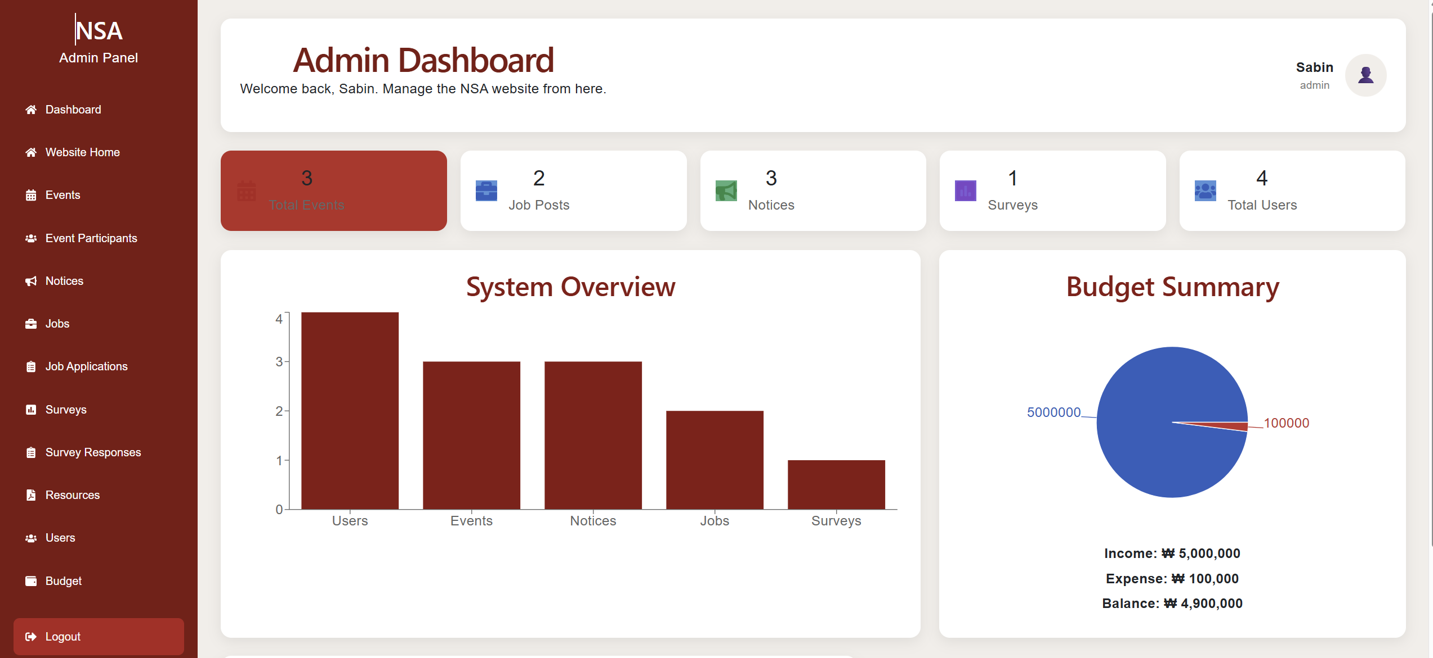
Figure 11: Administrator Dashboard Screenshot

- Event Management Interface
Administrators can create, edit, and delete events through an intuitive management panel.
Features:
- Event title
- Event description
- Date and time
- Location details
- Event status
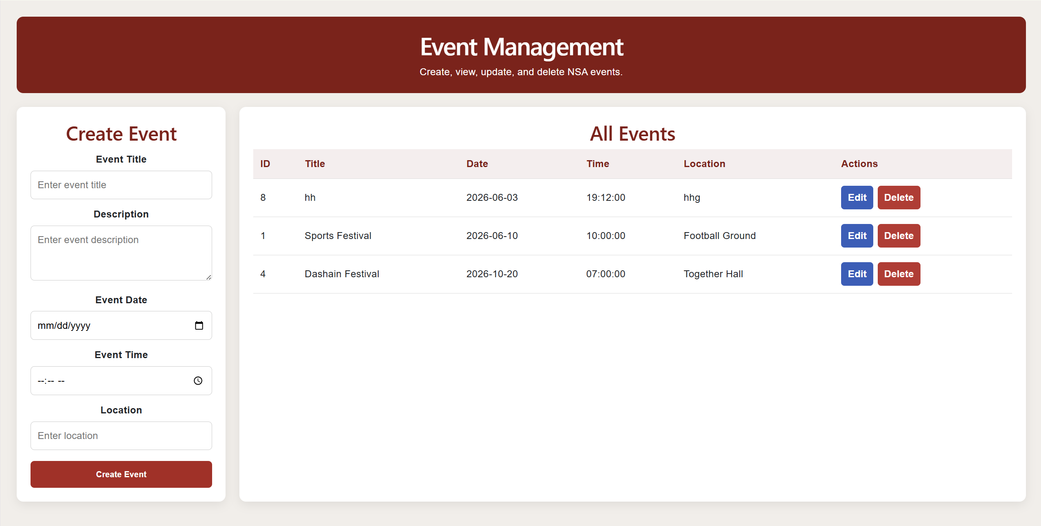
Figure 12: Event Management Interface

- Notice Board Interface
The Notice Board allows administrators to publish announcements and students to access information.
Features:
- Notice title
- Notice content
- Publication date
- Search functionality
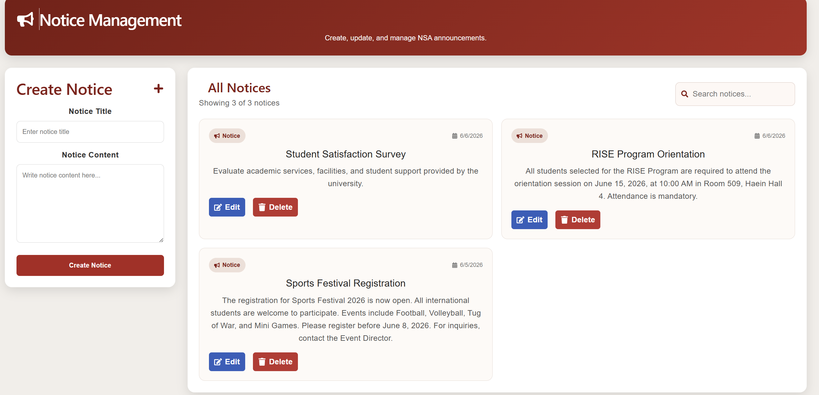
Figure 13: Notice Board Interface

- Job Portal Interface
The Job Portal provides employment opportunities for students.
Features:
- Job search
- Job filtering
- Job applications
- Application tracking
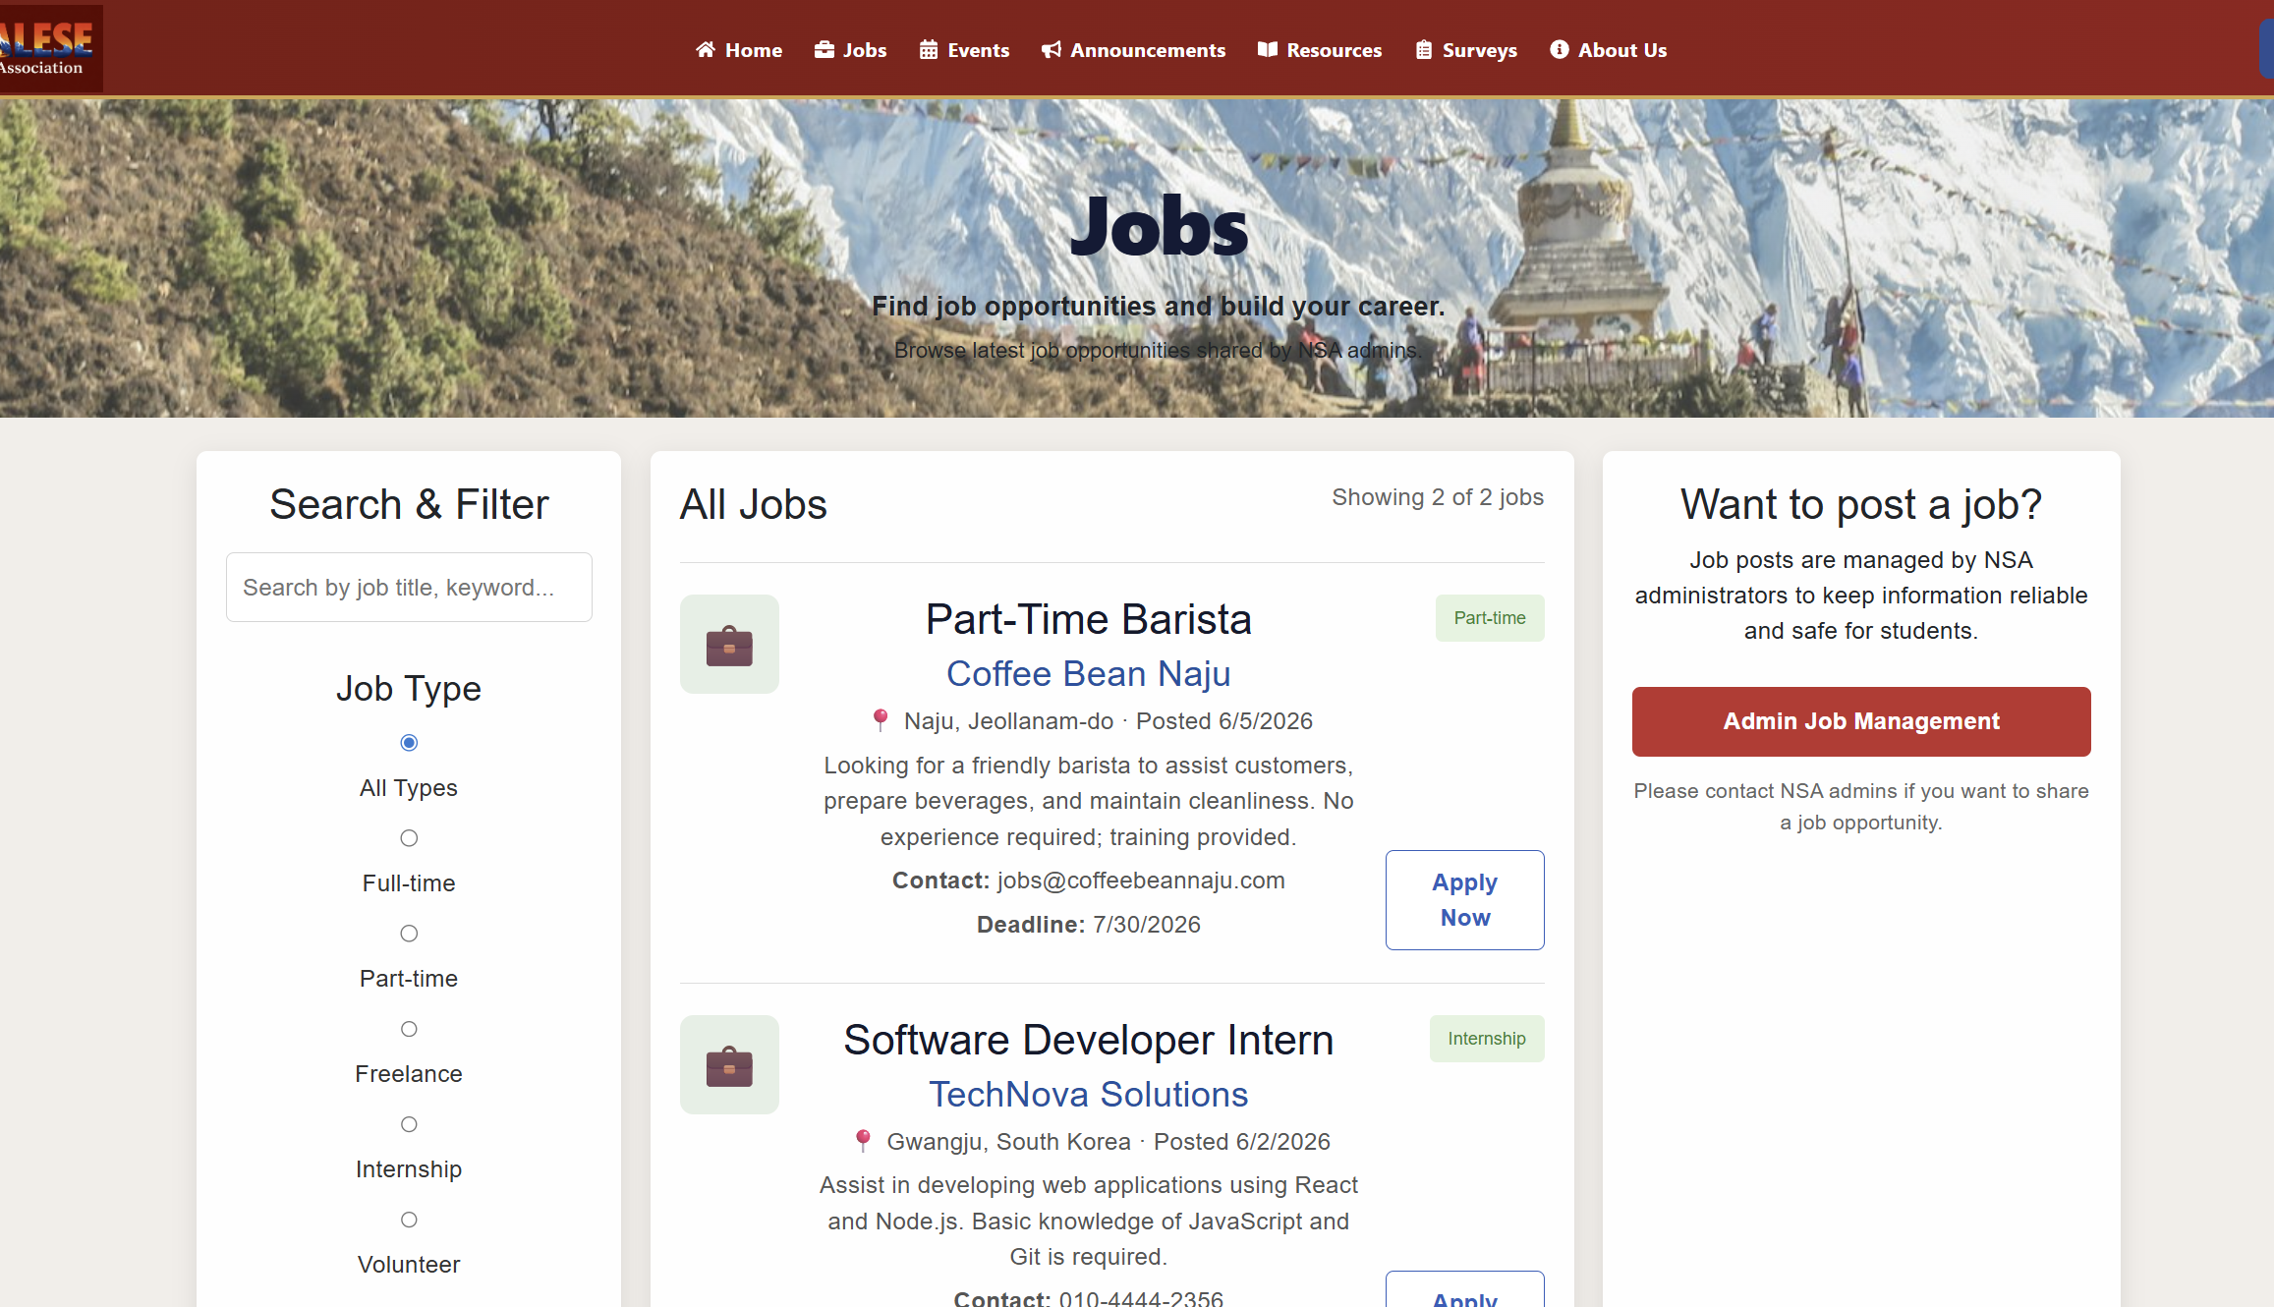
Figure 14: Job Portal Interface

- Survey Interface
Students can participate in surveys and administrators can create survey forms.
Features:
- Survey creation
- Survey response collection
- Duplicate submission prevention
- Survey analytics
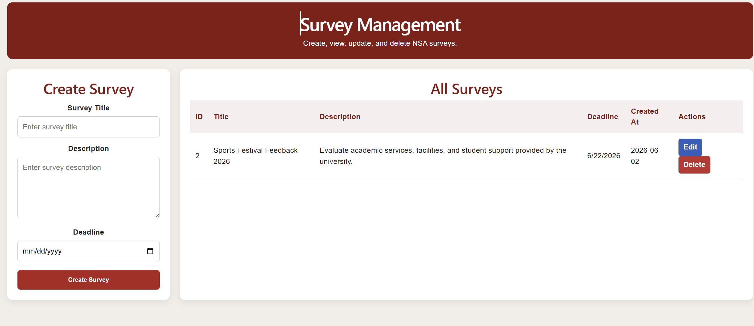
Figure 15: Survey Interface

Responsive Design
The interface supports:
- Desktop devices
- Laptop devices
- Tablets
- Mobile phones
Bootstrap's responsive grid system ensures consistent display across different screen sizes.

5.2 Static Model – Class Diagrams
The class diagram describes the static structure of the NSA Website system and illustrates the relationships between classes. The design follows object-oriented principles to improve maintainability and scalability. The class diagram is shown in the design document.
Main Classes
- User Class
The User class stores account information and authentication details.
Attributes:
- user_id
- name
- email
- password
- role
- department
- nationality
Methods:
- register()
- login()
- updateProfile()

- Event Class
The Event class manages association activities and schedules.
Attributes:
- event_id
- title
- description
- location
- date
Methods:
- createEvent()
- updateEvent()
- deleteEvent()

- Notice Class
The Notice class manages announcements.
Attributes:
- notice_id
- title
- content
- created_at
Methods:
- createNotice()
- updateNotice()
- deleteNotice()

- Job Class
The Job class manages employment opportunities.
Attributes:
- job_id
- title
- description
- location
- salary
Methods:
- createJob()
- updateJob()
- deleteJob()

- Survey Class
The Survey class manages survey forms.
Attributes:
- survey_id
- title
- description
Methods:
- createSurvey()
- updateSurvey()
- deleteSurvey()

- SurveyResponse Class
Stores survey responses submitted by students.
Attributes:
- response_id
- survey_id
- user_id
- response_text
Methods:
- submitResponse()

Relationships
- One User can submit many Survey Responses.
- One Survey can contain many Survey Responses.
- One Administrator can create multiple Events.
- One Administrator can publish multiple Notices.
- One Administrator can post multiple Jobs.
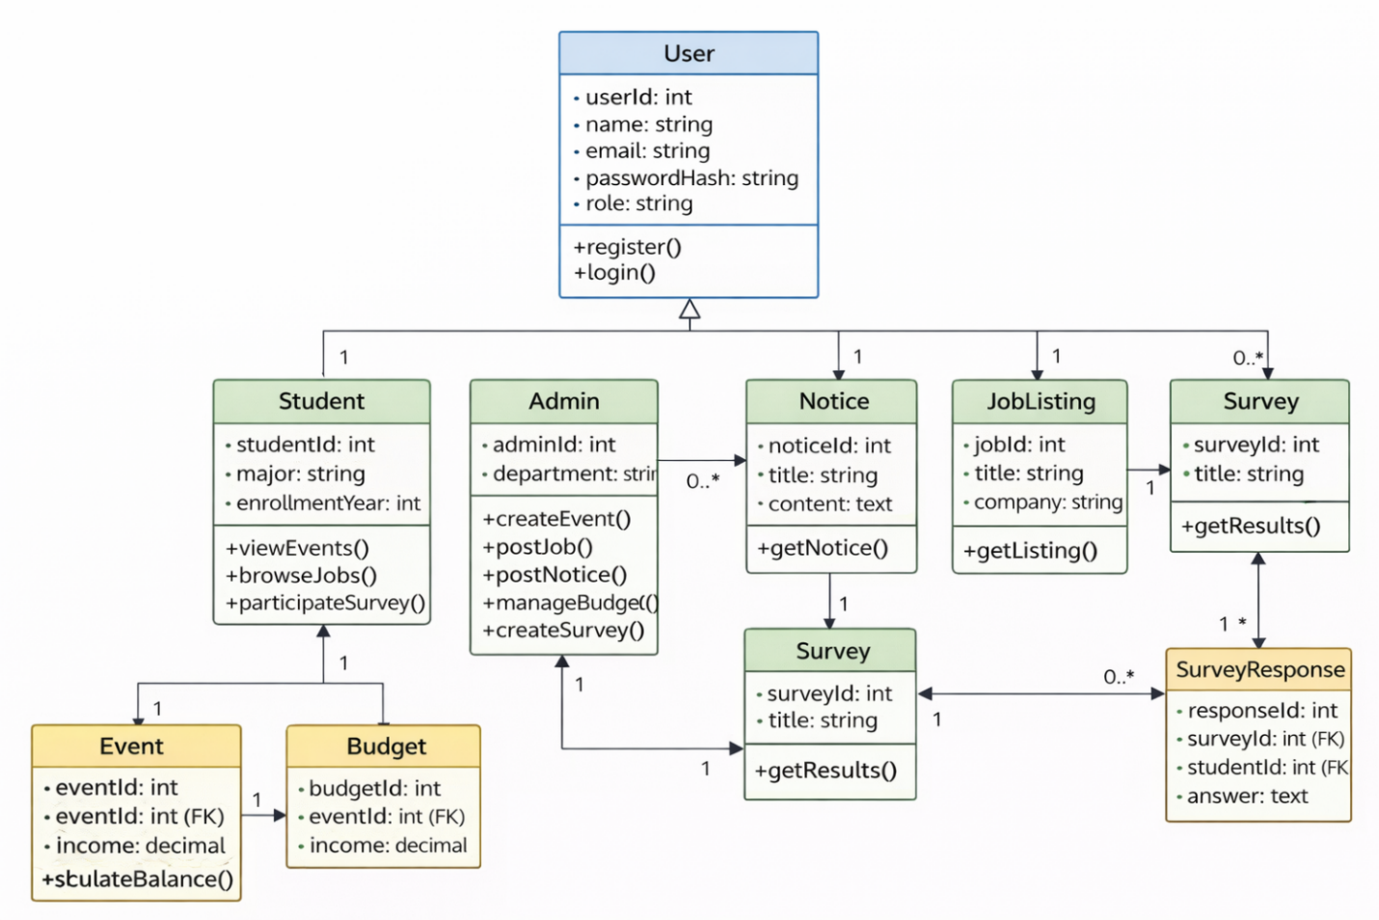
Figure 16: Class Diagram

5.3 Dynamic Model – Sequence Diagrams
Sequence diagrams describe interactions between system components over time.
The NSA Website includes four primary sequence diagrams.

- User Login Sequence Diagram
The User Login sequence describes the authentication process.
Process Flow
- User enters credentials.
- Frontend sends login request.
- Backend queries database.
- Database returns user record.
- Password is verified.
- JWT token is generated.
- Login response is returned.
- Dashboard is displayed.
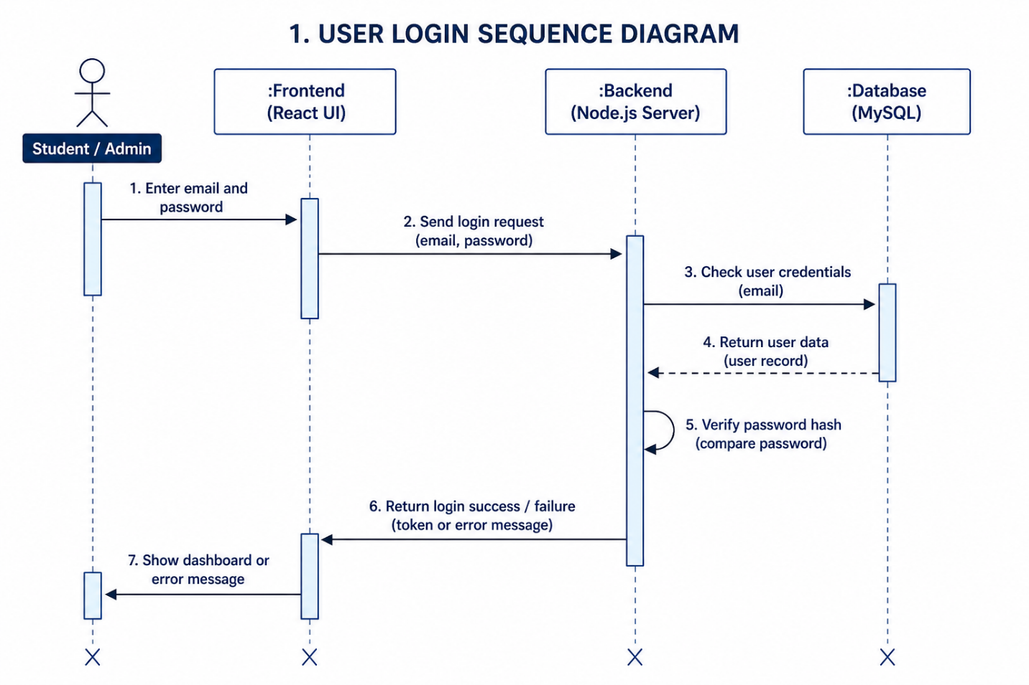
Figure 17: User Login Sequence Diagram

- Admin Creates Event Sequence Diagram
This sequence diagram illustrates event creation.
Process Flow
- Admin enters event information.
- Frontend submits event request.
- Backend validates admin role.
- Event data is inserted into database.
- Success response is returned.
- Event becomes available to students.
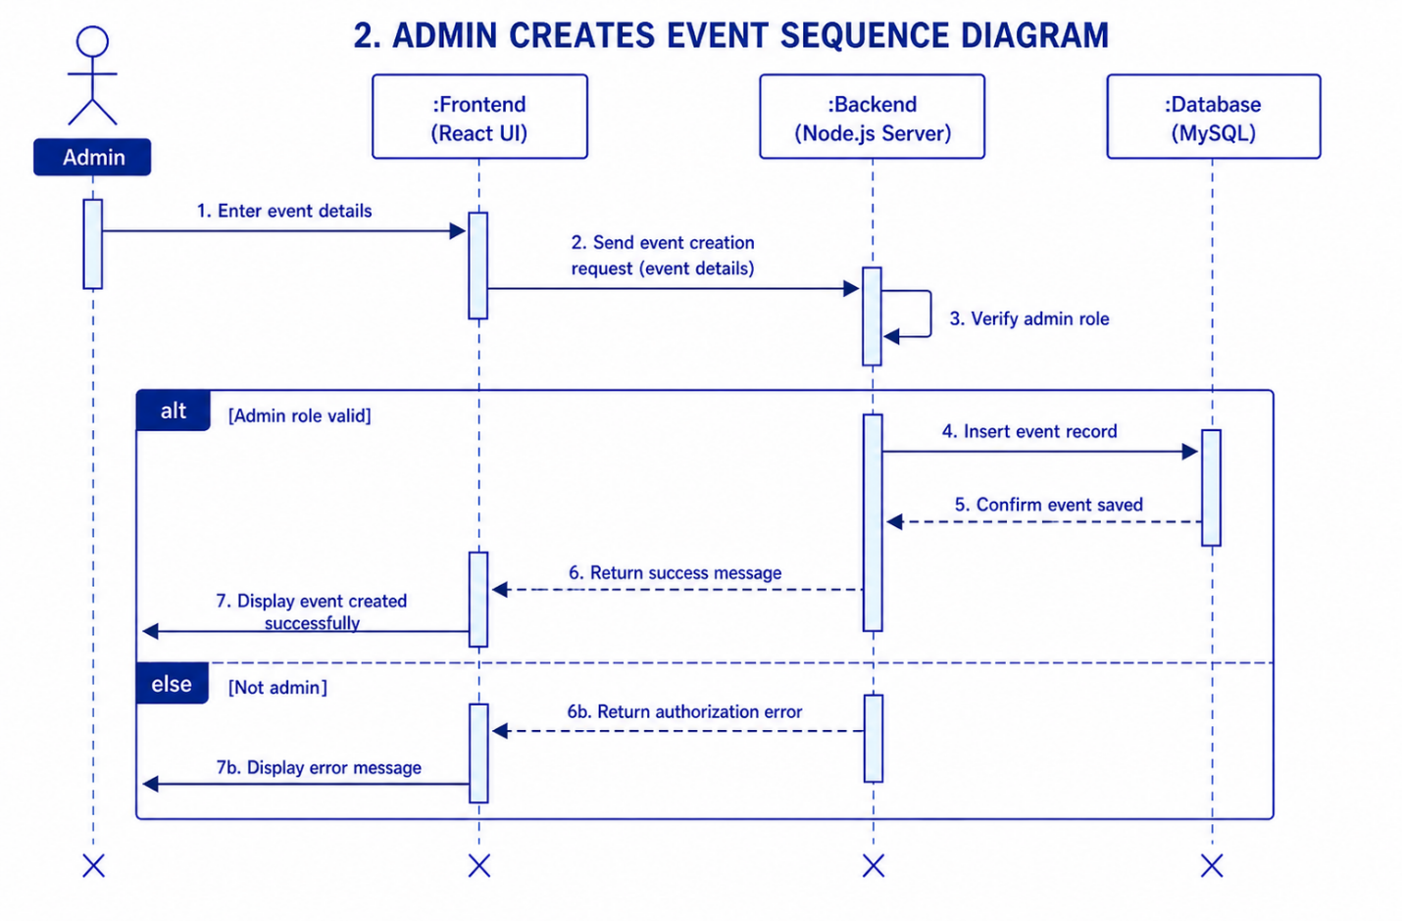
Figure 18: Admin Creates Event Sequence Diagram

- Student Submits Survey Sequence Diagram
This sequence diagram shows survey participation.
Process Flow
- Student selects survey.
- Student submits responses.
- Backend checks duplicate submission.
- Database stores response.
- Success message is displayed.
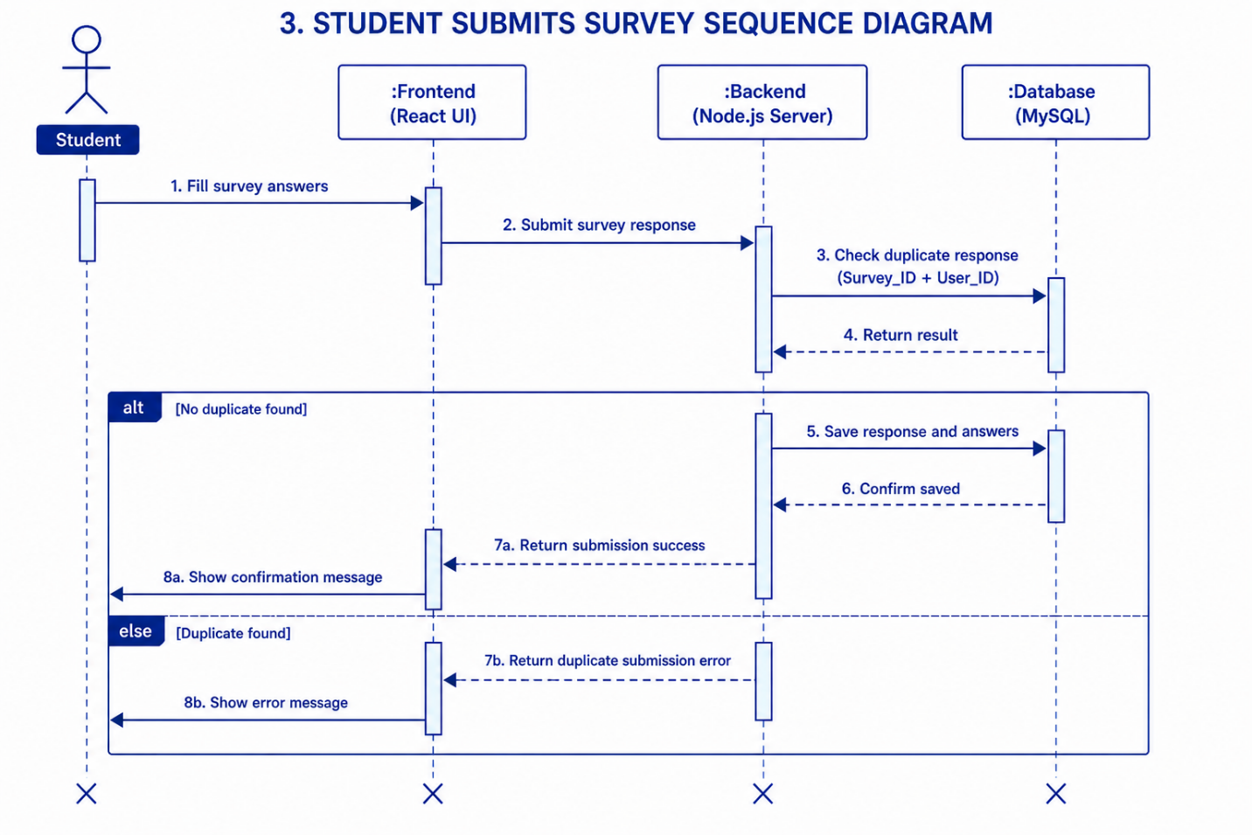
Figure 19: Student Submits Survey Sequence Diagram

- Admin Posts Job Sequence Diagram
This sequence diagram describes job posting.
Process Flow
- Admin enters job details.
- Backend verifies permissions.
- Database stores job information.
- Job becomes visible in Job Portal.
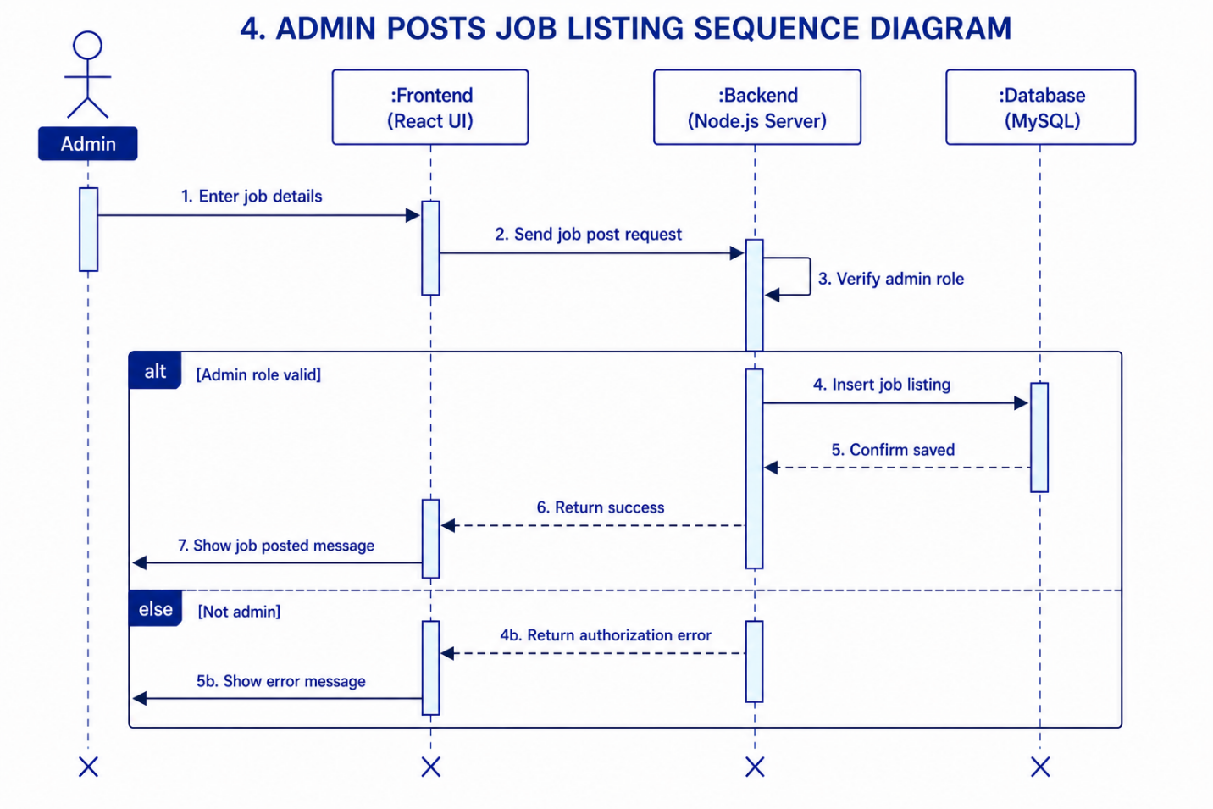
Figure 20: Admin Posts Job Sequence Diagram

5.4 Rationale for Detailed Design Model
The detailed design model was developed to provide a clear blueprint for implementation while ensuring consistency between requirements and system architecture.
Reasons for Using Class Diagrams
Class diagrams:
- Represent system structure.
- Identify relationships between entities.
- Support object-oriented design.
- Improve maintainability.
Reasons for Using Sequence Diagrams
Sequence diagrams:
- Describe system behavior.
- Illustrate communication between components.
- Help identify processing steps.
- Support testing activities.
Reasons for Using GUI Design Models
GUI models:
- Improve user experience.
- Reduce development errors.
- Provide visual guidance during implementation.
- Support stakeholder validation.
The combination of these models ensures that both structural and behavioral aspects of the system are properly documented.

5.5 Traceability from Requirements to Detailed Design Model
The traceability matrix ensures that every functional requirement is represented within the design models.
Requirement | Design Component
REQ-1 Event Management | Event Class, Event Sequence Diagram
REQ-2 Calendar View | Event Module, GUI Design
REQ-3 Job Management | Job Class, Job Sequence Diagram
REQ-4 Job Browsing | Job Portal Interface
REQ-5 Budget Management | Budget Module Design
REQ-6 Budget Viewer | Budget GUI Design
REQ-7 Notice Management | Notice Class
REQ-8 Notice Viewing | Notice Board Interface
REQ-9 Survey Management | Survey Class
REQ-10 Survey Submission | Survey Response Class, Survey Sequence Diagram
REQ-11 Authentication | User Class, Login Sequence Diagram
REQ-12 Registration/Login | Registration Interface
REQ-13 User Management | User Management Module
The traceability matrix demonstrates that every requirement identified during analysis is addressed by one or more design components, ensuring completeness and consistency throughout the development process.

Chapter 6
Test Plan
6.1 Requirements/Specifications-Based System Level Test Cases
Testing was conducted to verify that the NSA Website satisfies the functional and non-functional requirements specified in the Software Requirements Specification (SRS). The testing process focused on validating system functionality, usability, security, and reliability.
Testing Environment
Component | Description
Frontend | React.js
Backend | Node.js + Express.js
Database | MySQL
Deployment | Railway Cloud Platform
Browser | Google Chrome
Testing Tool | Postman
Operating System | Windows 11

Test Case TC-01: User Registration
Item | Description
Test Case ID | TC-01
Requirement | REQ-12
Objective | Verify account registration
Input | Valid registration details
Expected Result | User account created successfully
Actual Result | Account created successfully
Status | Pass
Procedure
- Open registration page.
- Enter student information.
- Request OTP.
- Verify OTP.
- Submit registration form.
Result:
The system successfully created a new account and stored user information in the database.

Test Case TC-02: User Login
Item | Description
Test Case ID | TC-02
Requirement | REQ-11
Objective | Verify authentication process
Input | Valid email and password
Expected Result | Successful login
Actual Result | Login successful
Status | Pass
Procedure
- Enter registered email.
- Enter password.
- Submit login request.
Result:
The system generated a JWT token and redirected the user to the dashboard.

Test Case TC-03: Invalid Login
Item | Description
Test Case ID | TC-03
Requirement | REQ-11
Objective | Verify login validation
Input | Invalid password
Expected Result | Error message displayed
Actual Result | Error displayed
Status | Pass
Result:
Unauthorized users were prevented from accessing the system.

Test Case TC-04: Password Reset
Item | Description
Test Case ID | TC-04
Requirement | REQ-11
Objective | Verify password recovery
Input | Registered email
Expected Result | OTP email delivered
Actual Result | OTP received successfully
Status | Pass
Result:
Password reset functionality worked correctly using Brevo email services.

Test Case TC-05: Event Creation
Item | Description
Test Case ID | TC-05
Requirement | REQ-1
Objective | Verify event creation
Input | Event details
Expected Result | Event stored successfully
Actual Result | Event created successfully
Status | Pass
Result:
Event information was stored and became visible to students.

Test Case TC-06: Event Update
Item | Description
Test Case ID | TC-06
Requirement | REQ-1
Objective | Verify event modification
Input | Updated event details
Expected Result | Event updated
Actual Result | Event updated
Status | Pass

Test Case TC-07: Event Deletion
Item | Description
Test Case ID | TC-07
Requirement | REQ-1
Objective | Verify event deletion
Input | Existing event
Expected Result | Event removed
Actual Result | Event removed
Status | Pass

Test Case TC-08: Notice Creation
Item | Description
Test Case ID | TC-08
Requirement | REQ-7
Objective | Verify notice publishing
Input | Notice details
Expected Result | Notice visible to students
Actual Result | Notice displayed
Status | Pass

Test Case TC-09: Notice Editing
Item | Description
Test Case ID | TC-09
Requirement | REQ-7
Objective | Verify notice update
Input | Updated notice
Expected Result | Notice updated
Actual Result | Notice updated
Status | Pass

Test Case TC-10: Job Posting
Item | Description
Test Case ID | TC-10
Requirement | REQ-3
Objective | Verify job posting
Input | Job information
Expected Result | Job appears in portal
Actual Result | Job displayed successfully
Status | Pass

Test Case TC-11: Job Browsing
Item | Description
Test Case ID | TC-11
Requirement | REQ-4
Objective | Verify job browsing
Input | Search keyword
Expected Result | Matching jobs displayed
Actual Result | Jobs displayed
Status | Pass

Test Case TC-12: Survey Creation
Item | Description
Test Case ID | TC-12
Requirement | REQ-9
Objective | Verify survey creation
Input | Survey details
Expected Result | Survey published
Actual Result | Survey created
Status | Pass

Test Case TC-13: Survey Submission
Item | Description
Test Case ID | TC-13
Requirement | REQ-10
Objective | Verify survey participation
Input | Survey response
Expected Result | Response saved
Actual Result | Response stored
Status | Pass

Test Case TC-14: User Authorization
Item | Description
Test Case ID | TC-14
Requirement | REQ-13
Objective | Verify role-based access
Input | Student attempting admin action
Expected Result | Access denied
Actual Result | Access denied
Status | Pass

6.2 Traceability of Test Cases to Use Cases
The following matrix demonstrates the relationship between use cases and corresponding test cases.
Use Case | Test Case
Registration | TC-01
Login | TC-02, TC-03
Password Reset | TC-04
Manage Events | TC-05, TC-06, TC-07
Manage Notices | TC-08, TC-09
Manage Job Listings | TC-10
Browse Jobs | TC-11
Manage Surveys | TC-12
Submit Survey | TC-13
Manage Users | TC-14
This traceability ensures that all major use cases are validated through testing activities.

6.3 Techniques Used for Test Generation
Several testing techniques were used throughout the project.
Black Box Testing
Black box testing was used to verify system functionality without examining internal implementation details.
Examples:
- Registration testing
- Login testing
- Event creation testing
- Job posting testing

Functional Testing
Functional testing verified whether implemented features satisfied specified requirements.
Examples:
- Authentication
- Survey participation
- Notice publishing
- Event management

Integration Testing
Integration testing ensured proper communication between system modules.
Examples:
- React frontend ↔ Express backend
- Backend ↔ MySQL database
- Backend ↔ Brevo Email API

User Acceptance Testing (UAT)
User Acceptance Testing was performed to ensure the system meets stakeholder expectations.
Focus areas:
- Ease of use
- Navigation
- User experience
- Information accessibility

6.4 Assessment of the Goodness of the Test Suite
The quality of the test suite was evaluated using several software testing metrics.
Requirement Coverage
Requirement coverage measures how many system requirements are tested.
Requirement Type | Coverage
Functional Requirements | 100%
Non-Functional Requirements | 80%
Requirement coverage was achieved through systematic mapping between requirements and test cases.

Use Case Coverage
Use Cases Tested | Coverage
12 of 12 Major Use Cases | 100%
All major user interactions were tested.

Pass Rate
Metric | Value
Total Test Cases | 14
Passed | 14
Failed | 0
Success Rate | 100%

Defect Detection
Several defects were identified and corrected during development, including:
- Database connection errors
- Railway deployment issues
- Package dependency conflicts
- OTP email delivery failures
- Authentication validation bugs
After corrective actions, the system passed all critical functional tests.

Reliability Assessment
The deployed system demonstrated:
- Stable cloud deployment
- Successful database connectivity
- Secure authentication
- Consistent API responses
The Railway deployment environment further improved reliability through managed hosting services.

Overall Testing Evaluation
The testing process confirmed that the NSA Website satisfies the majority of its specified requirements and performs reliably under normal operating conditions. The combination of functional, integration, and user acceptance testing provides confidence in the system's readiness for deployment and practical use by the Nepalese Student Association.

Acknowledgment
The project team would like to express sincere gratitude to Prof. Ibrahim Musa Ishag Musa for his valuable guidance, continuous support, and constructive feedback throughout the development of this project. His expertise and encouragement played a significant role in the successful completion of the NSA Website.
The team would also like to thank Dongshin University and the College of Glocal Autonomous Major for providing the resources, facilities, and academic environment necessary for completing this Software Engineering project.

References
[1] I. Sommerville, Software Engineering, 10th ed. Boston, MA, USA: Pearson, 2016.
[2] R. S. Pressman and B. R. Maxim, Software Engineering: A Practitioner's Approach, 9th ed. New York, NY, USA: McGraw-Hill Education, 2020.
[3] IEEE Computer Society, IEEE Recommended Practice for Software Requirements Specifications, IEEE Std 830-1998, 1998.
[4] React Team, “React Documentation,” Meta Platforms Inc. [Online]. Available: https://react.dev. [Accessed: Jun. 8, 2026].
[5] Node.js Foundation, “Node.js Documentation.” [Online]. Available: https://nodejs.org. [Accessed: Jun. 8, 2026].
[6] Express.js, “Express Web Framework.” [Online]. Available: https://expressjs.com. [Accessed: Jun. 8, 2026].
[7] Oracle Corporation, “MySQL Documentation.” [Online]. Available: https://dev.mysql.com/doc. [Accessed: Jun. 8, 2026].
[8] Railway, “Railway Documentation.” [Online]. Available: https://docs.railway.app. [Accessed: Jun. 8, 2026].
[9] GitHub Inc., “GitHub Documentation.” [Online]. Available: https://docs.github.com. [Accessed: Jun. 8, 2026].
[10] Bootstrap Team, “Bootstrap Documentation.” [Online]. Available: https://getbootstrap.com. [Accessed: Jun. 8, 2026].
[11] Axios Contributors, “Axios Documentation.” [Online]. Available: https://axios-http.com. [Accessed: Jun. 8, 2026].
[12] Brevo, “Brevo Email API Documentation.” [Online]. Available: https://developers.brevo.com. [Accessed: Jun. 8, 2026].

Appendix A – Project Resources
GitHub Repository:
https://github.com/sabin2002/NSA-website
Live System URL:
https://handsome-generosity-production-8a66.up.railway.app/
Backend API URL:
https://nsa-website-production.up.railway.app
Deployment Platform:
Railway Cloud Platform
Database:
Railway MySQL Database

